Handwriting
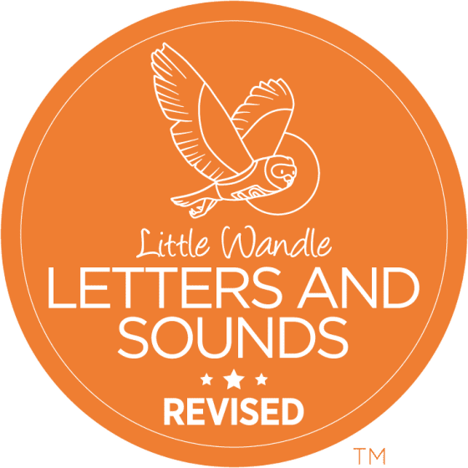

At Holley Park, we develop our handwriting by using two different schemes. Initially, we use Little Wandle: Letters and Sounds Revised in EYFS and Year 1 to help children develop their basic letter formation. From Year 2 onwards, we use the Letter-join scheme. This supports children to produce fluent cursive handwriting by the time they finish Year 6. We support this journey through the use of explicit modelling and daily opportunities for children to practise.
Although this progression document is organised into age-related content, we fully recognise that some children will require adaptations to this progression to ensure their individual needs are met.
EYFS
Opportunities to develop handwriting:
- to allow children to choose/develop their dominant hand.
- to explore and have the opportunity to develop a comfortable grip using a variety of malleable materials and graphic tools.
- to model anti-clockwise circles.
- to model lines from top to bottom.
- to model left to right orientation.
- to model correct pencil hold
- to practise correct letter formation
- to develop a conventional tripod pencil grip.
- to produce a controlled line which supports letter formation.
- to rehearse letter writing in the air whilst teacher demonstrates and gives verbal instructions, in line with Little Wandle: Letters and Sounds Revised scheme.
- to write letters using the correct sequence of movements.
- to space and regulate letters and words.
- to write from left to right and top to bottom of the page.
Throughout Reception:
- Consolidate the correct formation of digits 0 – 9
- To develop core strength when writing by sitting correctly at a table.
- To develop handwriting fluency through regular practise of the formation of lower-case and upper case letters in the correct direction, starting and finishing in the right place in line with Little Wandle: Letters and Sounds Revised.
- to begin to form lower case letters of the correct size relative to one another
- To use spaces between words

Reception Autumn 1:
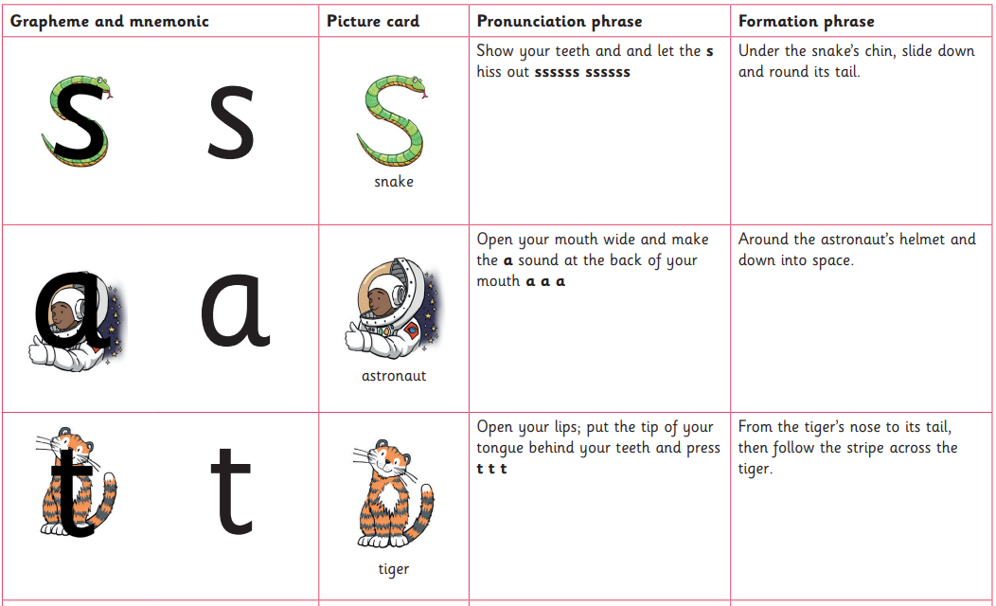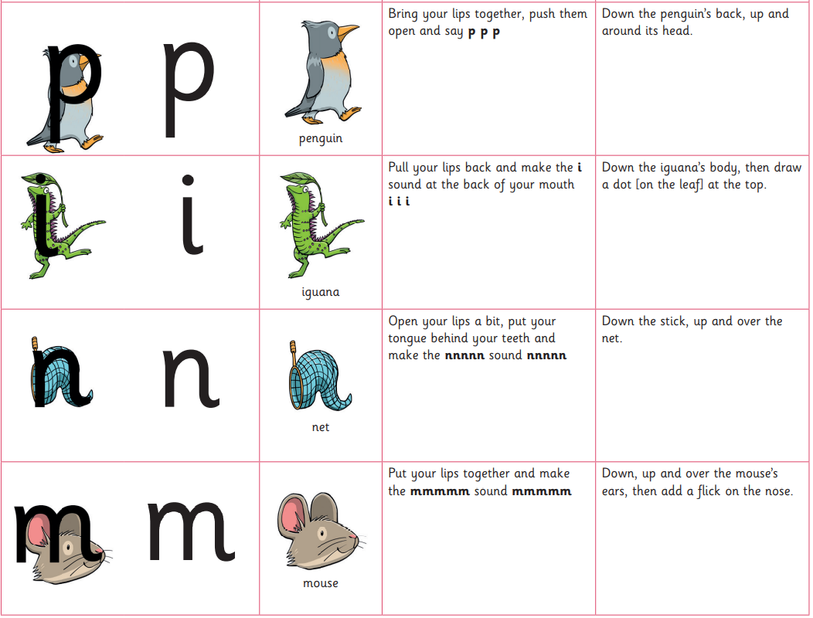
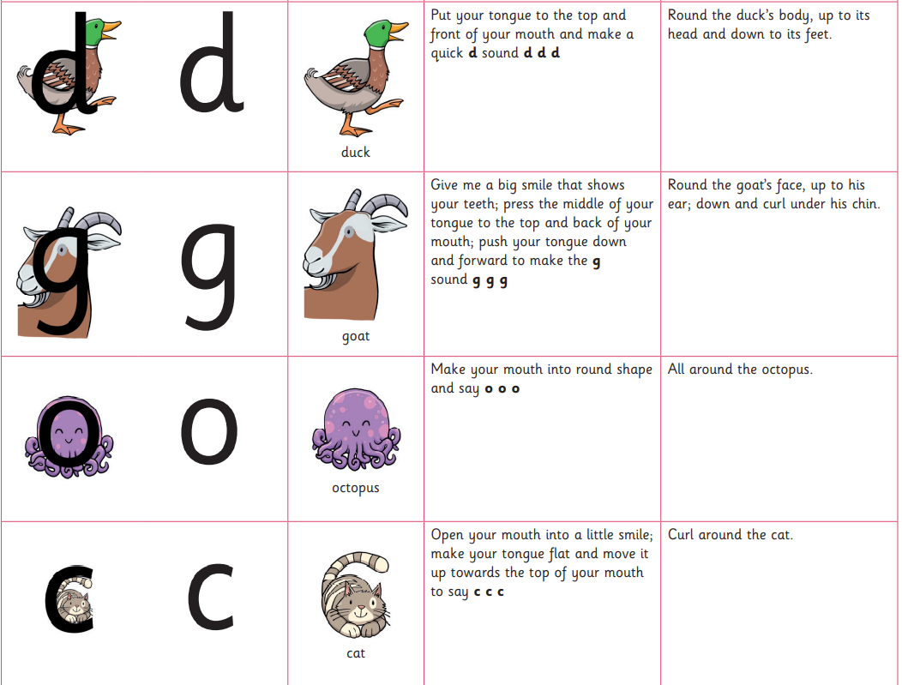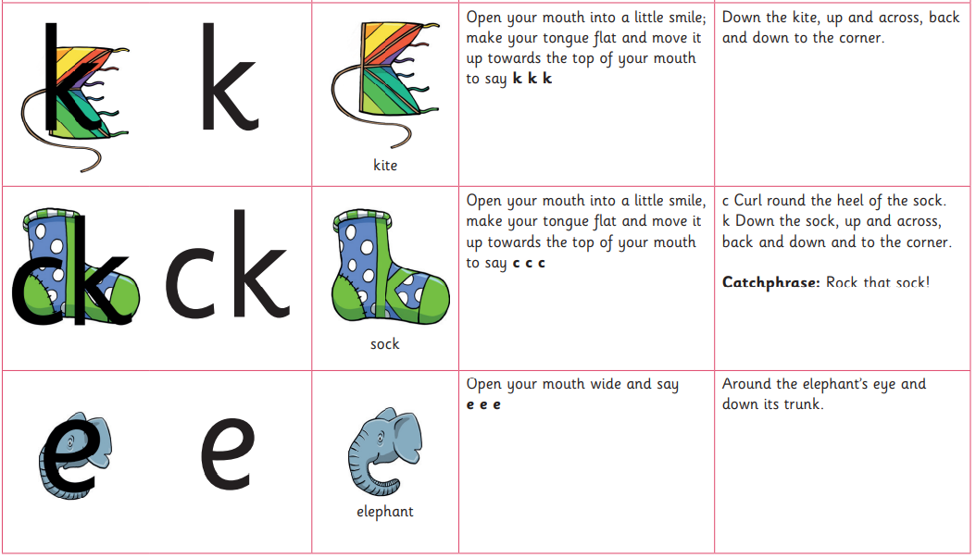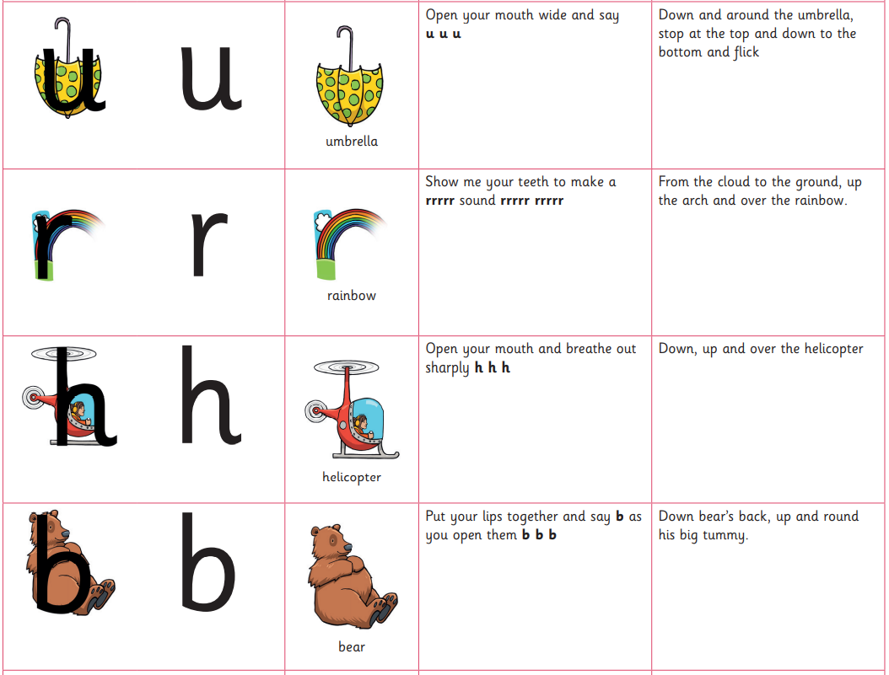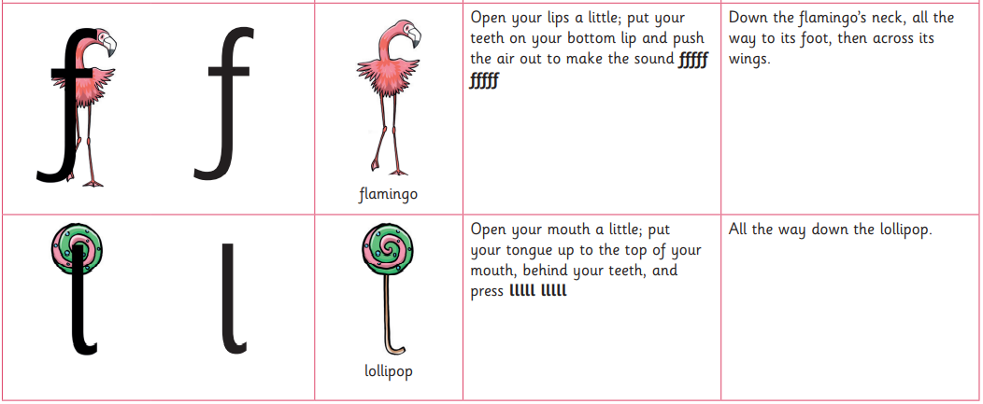

Reception Autumn 2:
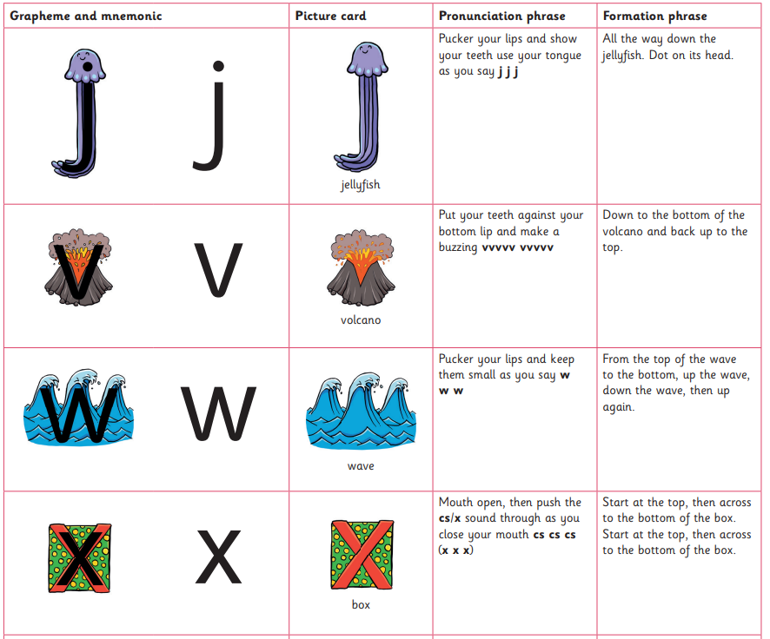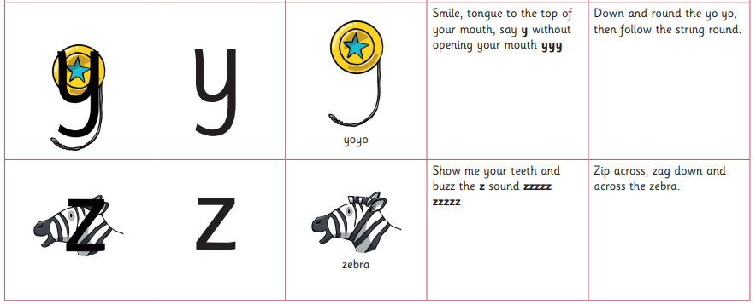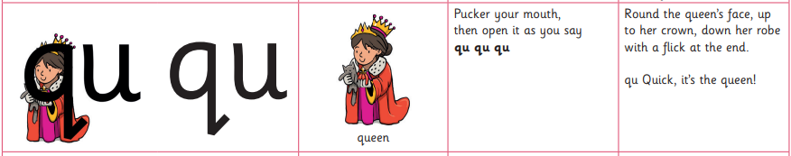
Capital Letter formation:
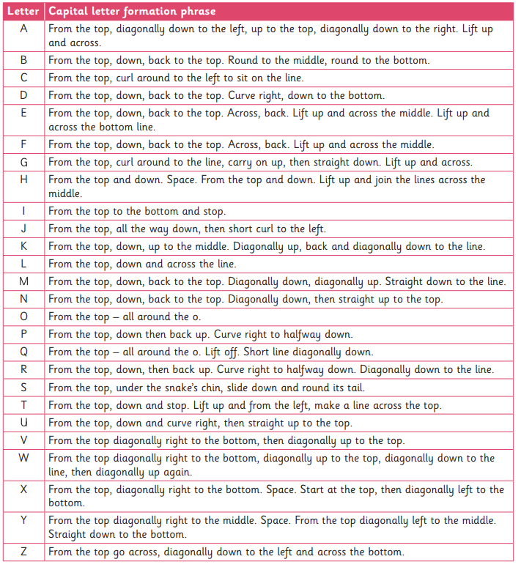

Year 1
Throughout Year 1:
- to consolidate a conventional tripod pencil grip.
- to continue to consolidate and further develop fluency of the accurate formation of lower-case and uppercase letters in the correct direction, starting and finishing in the right place in line with Little Wandle: Letters and Sounds Revised
- to consistently form lower case letters of the correct size relative to one another
- to practise handwriting in conjunction with spelling and independent writing
Year 2
Year 2 autumn and spring terms:
- to consolidate size, proportion, spacing and legibility of all lower- and upper-case letters.
- to practise handwriting in conjunction with spelling and independent writing, ensuring correct letter orientation, formation and proportion
Year 2 summer 1:
- Letter formation of all lowercase letters to be taught in order:

Year 2 Summer 2:
- Practise joining easy letters to each other in order for children to demonstrate they are able to use the diagonal and horizontal strokes needed to join some letters:
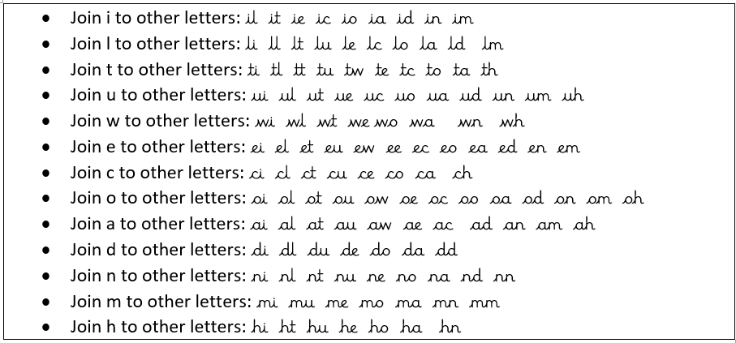

Year 3 Autumn 1:
- Revisit all basic letter formations and easy joins learnt in Year 2, allowing for more time to be given to any aspects of formation that may require additional practise in order to secure pupil fluency
- Consolidate easy words join using examples such as below:
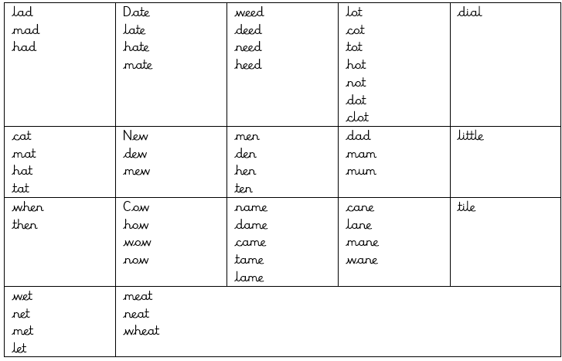
Year 3 Autumn 2:
- Moving onto practising joining harder letters:
to easy letters
Year 2 Summer 1:
- Practise joining hard letters:
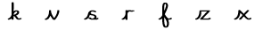to all other easy and hard letters.

Throughout Year 4:
- to build up speed and continue to consolidate consistency in size, proportion, fluency and spacing between letters and words.
- to use a range of presentational skills, e.g. print script for captions, sub-headings and labels; capital letters for posters, title pages and headings etc.
Throughout Year 5:
- to continue to consolidate consistency in size, proportion, fluency and spacing between letters and words.
- to revise all rules for joining.
- to develop fluency and speed of own style.
- to use joined handwriting for all writing except where other special forms are required.
- to know when to use:
- a clear neat hand for finished, presented work.
- informal writing for everyday informal work, rough drafting etc.
Throughout Year 6:
- to consolidate and develop individual fluent and legible style.
- to learn to write in differing scripts e.g. italic
- to use scripts appropriately for different purposes.
- to continue progress in joining by observing different features affecting neatness.

