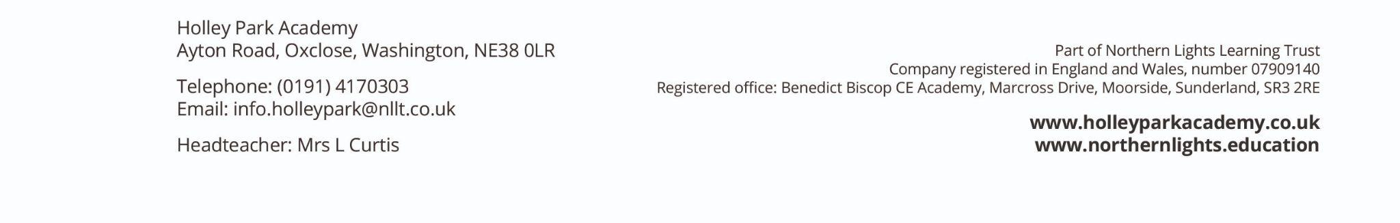
Wednesday 4th March 2026

Dear Parents and Carers,

I hope you are well.

I am writing to update you on some recent changes within the leadership team at Holley Park Academy. As many of you will know, Mrs Curtis has recently been absent from school. She has now made the decision to resign from her role as of the end of April.

We would like to take this opportunity to thank Mrs Curtis for her valued contribution to the school during her time as Headteacher at Holley Park and wish her every success for the future.

During her absence, Mr Garrett, Deputy Headteacher, has been leading the school day to day. I am pleased to confirm that Mr Garrett will continue to provide this leadership in the interim and will take on the role of Acting Headteacher throughout the Summer term. I know the school community will join me in offering him their full support.

Looking further ahead, we have begun the process to appoint a Head of School from September 2026.

During this period, the school will be supported by Leanne Yates, Associate Headteacher at Northern Lights Learning Trust. Mrs. Yates is an experienced Headteacher. Please be assured that providing stability and maintaining the very best for our pupils remains our absolute priority.

If you have any questions or would like to discuss anything further, please do not hesitate to get in touch with Mr Garrett in the first instance, and Mrs Yates if required.

Thank you for your continued support of Holley Park Academy.

Warm regards,
Jo Heaton OBE
Chief Executive Officer
Northern Lights Learning Trust

