SEND Information Report
(July 2026)
SENDCo: Lee Garrett
Assistant SENDCo: Justine Whyte
SEND Governor: Chris James
Contact: lee.garrett@nllt.co.uk 0191 4170303
Local Offer Contribution: Local Offer | Sunderland Information Point

Whole School Approach:
High quality first teaching and additional interventions are defined through our annual dialogue across the school contributing to our provision management approach. These documents help us to regularly review and record what we offer EVERY child/young person in our care and what we offer additionally. These discussions also serve to embed our high expectations amongst staff about quality first teaching and the application of a differentiated and personalised approach to teaching and learning. We make it point to discuss aspirations with ALL our learners.
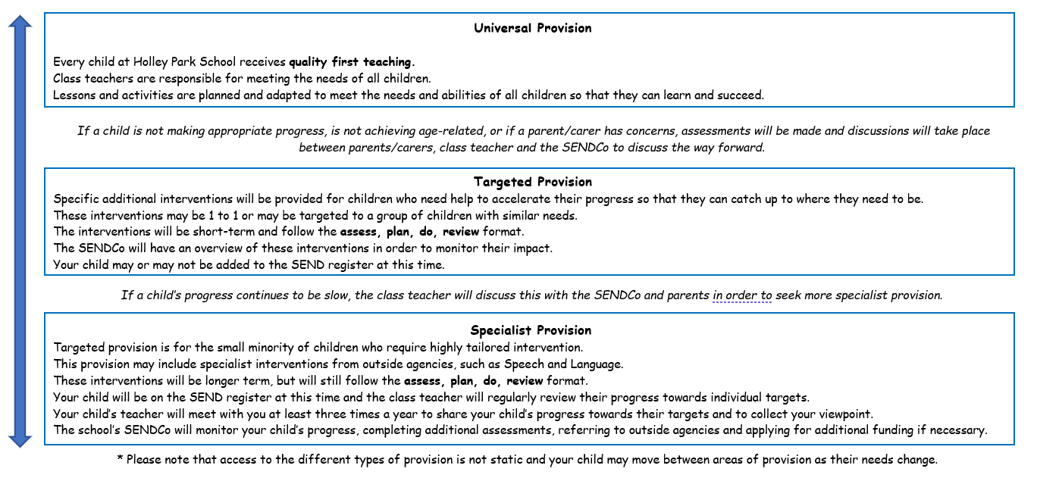

Underpinning ALL our provision in school is the graduate approach cycle of:


Identifying and assessing pupils with SEND:

The following steps will be taken to identify children who need to be added to the SEND register:
Step 1: Initial Discussion
ASSESS | Initial discussions take place between the SENDCo and/ or teachers, families/carers, and teaching assistants.  This will allow the SENDCo to ascertain if school and the families/carers share the same concerns.
Step 2: Assessments
ASSESS | School begins to gather information about the child by asking all relevant parties complete an assessment of the child (see overleaf).  Families/carers should complete and return this to school following the initial discussion.
Step 3: Discussion
ASSESS AND DO | The SENDCo draws out key information from the completed assessments in step 2 and holds a discussion with families/carers and school staff about the shared findings.  The SENDCo informs families/carers and staff of the next steps.
Step 4: Observation
ASSESS AND DO | The SENDCo carries out observations of the child in both their classroom environment and during lunch and breaktimes.  The SENDCo draws out key findings from observations to form part of their feedback.
Step 5: Feedback
REVIEW | A meeting is held between the teacher, teaching assistant and families and carers - facilitated by the SENDCo.  SENDCo feeds back on key findings from the observation and provides no more than 3 next steps.  The SENDCo will arrange to observe again after a period of 3 weeks in order to review the actions that were set.
Step 6: Observation
REVIEW | The SENDCo will observe the child again, looking for progress made against the next steps that were previously set.  From this observation, the SENDCo decides on what needs to happen next.
Step 7: Feedback
REVIEW | A meeting takes place between the SENDCo, families/carers, teacher and teaching assistant.  The SENDCo feeds back on key findings from the 2nd observation and the next steps of action.  If SEND registration is required, the area of need will be discussed.
Step 8: Initiate.
PLAN AND DO | If required, the child is added to the SEND register.  A Support Plan is written,  Where appropriate, referrals will be made to other professionals (Speech & Language, Occupational Therapy etc.)  If required, EHC plans will be started.  In class support will be provided (resources, outreach, intervention etc)  Support will be offered for families/carers.

All teachers are responsible for every child in their care; including those with special educational needs.

Once a support plan has been created after having consulted with children, young people and their families, all our additional provision (internal or external) is based on an agreed outcomes approach and will follow the following cycle:

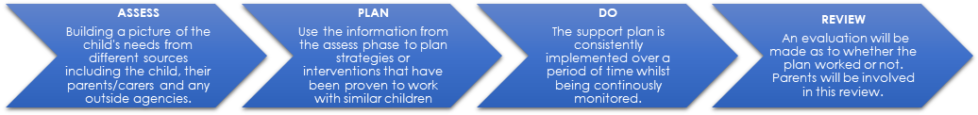

SEND Needs:

As of July 2026, we had 20 children (10% of the school) receiving some form of SEN Support across school.

Children and young people’s SEND are generally thought of in the four broad areas of: communication and interaction, cognition and learning, social, emotional and mental health, and Sensory and/or physical needs.

Some of the strategies used by school to support pupils over the course of this academic year have included:

Communication and Interaction
- Classroom access to a range of sensory toys and equipment (including weighted scarves, ear defenders, snap bands, trampets etc.)
- Use of sensory circuits for specific pupils
- Explicitly taught skills and model rules of social interaction, for example though age-appropriate social stories.
- Tailored timetables and adult support where necessary to maximise preparedness for learning
- Positively reinforced good behaviour in line with the school’s Behaviour Policy and/ or with individualised motivators where appropriate.
- Used visual supports to define areas and structure the day, for example, visual timetable or ‘Now and Next’ boards.
- Use of communication boards and jigs (developed through use of the Widget programme/ Twinkle Symbols)
- Gave pupils a specific role in group work to support their interaction
- Understood and managed potential health and safety considerations, for example lack of an awareness of danger about running away/off site or using certain equipment.
- Ensured pupils are seated in the best place to reduce distraction
- Each pupil’s special interests were incorporated to focus attention and increase motivation.
- Staff checked that information has been understood, by asking the child to explain what they have to do rather than repeating instructions.
- An appropriate level of language was used, with short, simple sentences if needed.
- Sought external support from agencies:
Service | Website | Number of referrals school has made this academic year
Autism Outreach Team | Sunderland Autism Outreach Team - Home | 2
Children and Young Peoples Service | Children and Young People's Service - South Tyneside and Sunderland - CNTW166 - Cumbria, Northumberland, Tyne and Wear NHS Foundation Trust | 4

Cognition and Learning

- The use of metacognition strategies to support children’s learning and inform teachers’ assessment of pupils
- Regularly monitored pupil’s understanding by asking the pupil to show or explain the instructions in their own words
- Provided scaffolding and resources to support children accessing their learning task or differentiating the task if necessary. This has included the use of Colourful Semantics in writing
- Used same-day catch up interventions when required and the use of specific targeted interventions for example Little Wandle Catch-up Programme for early reading, Power of Two and Plus One for maths
- Provided additional processing time to respond to questions and tasks
- Provided opportunities for repetition and reinforcement
- Gave information in small steps in clear, concise language
- Related the work to the pupil’s direct experience whenever possible and avoid the use of ambiguities
- Encouraged the pupil to use strategies to process information e.g. silent rehearsal of instructions, identifying the important words in the instruction etc.
- The use of digital resources used to support learning. For example, reader pens, Padlet app etc.
Sought external support from agencies:
Service | Website | Number of referrals school has made this academic year
Language and Learning Partnership | Language and Learning Partnership | Sunderland Information Point | 1
Educational Psychologist | N/A | 4
Speech and Language Team | Speech and language therapy :: South Tyneside and Sunderland NHS Foundation Trust | 4

Social, Emotional and Mental Health
- Deployment of Thrive strategies, including use of PACE and ‘WIN’ language, as well as targeted interventions where appropriate. This year, 9 pupils have accessed some form of Thrive support, including 3 SEND pupils.
- Provided access to the school nurture provision to support children to develop their self-confidence and develop coping mechanisms. This year, 15 pupils have accessed our Nurture Provision, including 8 SEND pupils.
- Developed a knowledge of the pupil and possible triggers and help to strengthen the pupil’s self-confidence and help them to develop and implement coping strategies, such as breathing and expressive writing.
- Anticipated impending sensory overload to intervene at an early stage, or allow the pupil to remove themselves from the situation
- Used ‘Positivity Journals’ for specific pupils.
- ‘Zones of Regulation’ principles embedded across school to support emotional regulation
- Launch of ‘Healthy Heads’ programme to provide 1:1 and small group intervention for mental health and wellbeing, ran by a trained mental health worker
- Trained staff’s use of positive handling and escalation techniques when necessary to support pupil safety
- Adaptations to rooms and timetabling to support regulation
- Development of ‘RESET ROOM’ to support children to discharge negative emotions
- Developed regulation and safety plans for specific pupils to support their access to learning in school
- Prepared the pupil for new or unusual experiences whenever possible
- Shared potential support services to families and carers, such as kooth (Home - Kooth), Lumi Nova (Lumi Nova: Tales of Courage), Links for Life (Mental Health: Children and Young People | Links for Life Sunderland) and the Rainbow Guide (Choice Wellbeing Service CIC | Special Needs | Rainbow Family Hub, Elliott Terrace, Concord, Washington, UK)
- Sought external support from agency:
Service | Website | Number of referrals school has made this academic year
Children and Young People’s Mental Health Services | Sunderland Community Child and Adolescent Mental Health Service (CAMHS) :: South Tyneside and Sunderland NHS Foundation Trust | 5
Healthy Heads | Mental Health Support Service: Healthy Heads Team :: South Tyneside and Sunderland Mental Health Services | 6

Sensory and/or physical needs

- Classrooms have been adapted to reduce visual or auditory distraction where necessary
- Provided opportunities for alternative forms of recording e.g. use of Padlet app
- Consideration of children’s seating/ positioning in the classroom
- Use of adapted assessment materials
- Provided use of psychical resources/ interventions where necessary to support pupil’s access to the curriculum, e.g. pencil grips, Write Away intervention programme etc.
- Staff have used agreed verbal and visual cues when necessary.
- Clear expectations of activities have been established with visual cues where appropriate
- Teaching areas have been kept tidy and uncluttered to support pupils’ access to the environment.
- Sought external support from agency:
Service | Website | Number of referrals school has made this academic year
0-19 Service | Growing Healthy 0-19 Sunderland | HDFT Childrens Health Service | 3
Occupational Therapy | Children's Occupational Therapy | Sunderland Information Point | 3
Paediatrics | NA | 1

Wider-curriculum Engagement:

We ensure that all children have access to wider curriculum opportunities across school. This year 75% of our SEND pupils have accessed some form of wider-curriculum provision including: themed afterschool clubs, wrap-around care, Breakfast Club, music tuition and a range of educational visits.

Improving the Emotional and Social Development of Children with SEND:

Aside from promoting academic progress, we are committed to supporting the wider social and emotional development of our pupils. This year, we have supported this through our PSHE curriculum, MyPath career resources, and our No Outsiders programme (focused on Fundamental British Values and the Protected Characteristics). In addition to this we have also provided wider-curriculum opportunities for all year groups, including:
- Nissan workshops around sustainability .
- Trust ‘One Voice’ choir performances
- NHS workshops around puberty and hygiene
- GAS Network workshops
- Durham University history workshops
- Y6 Derwent Hill residential visit.
- Musical instrument tuition
- Y5 Bike Ability Programme.
- Y1 Walkwise programme.
- EYFS Stay and Play sessions to develop home-school partnerships.
- City-wide sporting competitions and celebrations.
- Development of Head Pupils group and Sports Leaders

Evaluation of the Effectiveness and Impact of Provision:

We have internal processes for monitoring quality of provision and assessment of need. This includes:
- Termly moderation of SEND support plans by the SENDCo to monitor children’s progress against their individual targets,
- Annual review led by the Northern Lights Learning Trust to evaluate the school’s current SEND provision and identify potential next steps for development
- Termly feedback to the Local Governing Body on SEND by the SENDCo
- SEND is also a thread that runs through all lesson visits and work moderations conducted by the Senior Leadership Team and external partners.

Consulting with Children, Young People and their Families:

Involving families and learners in the dialogue is central to our approach, in addition to annual parent and pupil voice questionnaires, we achieve this through termly meetings with families/ carers as part of the review process for children’s individual support plans. An additional fourth parental meeting is held in the summer term as part of children’s transition into their next year group. The voice of the child is also incorporated into this process. In addition to this formalised process, class teachers and the SENDCo will also regularly seek contact families/ carers with any updates or relevant information regarding their child’s learning journey, personal development, and well-being. Annual reviews are held for children with Educational Health Care Plans.

Looked After Children who also have SEND:

At present, we have 0 Looked After or Post Looked After pupils who are on the SEND register.

Staff Development:
We are committed to developing the on-going expertise of our staff. The following outlines the continued professional learning staff have engaged with regarding SEND:

Role | Area of expertise | Level (as per p68-9 of SEND Code of Practice 2015)
Class teachers  All staff | Supporting Pupils with Dyslexia  Developing Writing and Spelling  Adaptive Practice in Physical Education  Colourful Semantics  Supporting Learners in Music  Supporting Assessment in Science  Allergy and Anaphylaxis Awareness  Online Safety  Equality, Diversity and Inclusion Awareness | Awareness
SENDCo and Assistant SENDCo  Maths Lead  EVC Lead  Assistant Headteacher  Thrive Practitioner | SEND Leadership (National Professional Qualification)  Maths Leadership (National Professional Qualification)  Educational Visits Coordination  Administering Medication  Helping Young Children with Big Worries  ‘Softening the Prickles’: Enchanting Self-awareness and Resilience | Enhanced

Staff Deployment:
Considerable thought, planning and preparation goes into utilising our support staff to ensure children achieve the best outcomes, gain independence and are prepared for adulthood from the earliest possible age. Support staff are timetabled to ensure that children receive the support they need, this could be one a one-to-one basis to deliver bespoke intervention or small group support to fulfil individual targets outlined on children’s support plans. Staffing across this year has been comprised of 9 teachers, 1 ITT, 2 HLTAs and 2 TAs.

Arrangements for pupils with a disability
- The arrangements for admission of disabled persons as pupils at the school;
- The steps taken to prevent disabled pupils from being treated less favourably than other pupils;
- The facilities provided to assist access to the school by disabled pupils;
- The plan prepared by the governing body under paragraph 3 of Schedule 10 of the Equality Act 2010 (Accessibility Plan).

A full list of our external partners who we work with can be found in our contribution to the Local Offer. Extending our school approach, we commission using an outcomes-based approach. This enables us to hold our partners and ourselves to account.

School Partnerships and Transitions:
Our academic assessment for children with special educational needs is moderated through our cluster of schools and Local authority partners.

This year, we have supported 3 SEND children to transition to the next phase in education. To support a successful transition, school liaised with the SENDCos of the destination schools to discuss the provision in place for these children and ensured all relevant records were securely passed on. Families and carers were included in these discussions whenever possible.

We closely monitor children and young people’s destination data.

Complaints:
Our complaints procedure is available to view here: LCO (northernlights.education)

Further development
Our strategic plans for developing and enhancing SEND provision in our school next includes continuing to strengthen quality first teaching through supporting teachers to deploy effective adaptive practice when delivering the curriculum. Strengthening our offer around preparing pupils for adulthood (including developing our offer around careers education) will also be a focus moving into the academic year 2026 – 2027.

Relevant school policies underpinning this SEND Information Report include:

- Accessibility Policy
- Behaviour Policy
- Child Protection Policy
- Early Years Foundation Stage Policy
- Intimate Care Policy
- Relationships and Health Policy

Legislative Acts taken into account when compiling this report include:
- Children & Families Act 2014
- Equality Act 2010
- Mental Capacity Act 2005

Date to be presented to Governing Body: Autumn 2026-2027

