A COMPLETE PHONICS RESOURCE TO SUPPORT CHILDREN
Phonics and early reading policy
At Holley Park Academy, we show fidelity to the Little Wandle: Letters and Sounds Revised scheme as our platform to teach early reading. The scheme, taught from EYFS to Year 1, is used to teach children that sounds are represented by letters and that these sounds can be blended together to form words.
It is essential that our approach to teaching phonics and reading is accessible to all learners, regardless of background.
Intent
Phonics (reading and spelling)
At Holley Park Academy, we believe that all our children can become fluent readers and writers. This is why we teach reading through Little Wandle Letters and Sounds Revised, which is a systematic and synthetic phonics programme. We start teaching phonics in Nursery/Reception and follow the Little Wandle Letters and Sounds Revised progression, which ensures children build on their growing knowledge of the alphabetic code, mastering phonics to read and spell as they move through school.
As a result, all our children are able to tackle any unfamiliar words as they read. At Holley Park Academy, we also model the application of the alphabetic code through phonics in shared reading and writing, both inside and outside of the phonics lesson and across the curriculum. We have a strong focus on language development for our children because we know that speaking and listening are crucial skills for reading and writing in all subjects.
Comprehension
At Holley Park Academy, we value reading as a crucial life skill. By the time children leave us, they read confidently for meaning and regularly enjoy reading for pleasure. Our readers are equipped with the tools to tackle unfamiliar vocabulary. We encourage our children to see themselves as readers for both pleasure and purpose.

Because we believe teaching every child to read is so important, we have a Reading Leader who drives the early reading programme in our school. This person is highly skilled at teaching phonics and reading, and they monitor and support our reading team, so everyone teaches with fidelity to the Little Wandle Letters and Sounds Revised programme.
Implementation
Foundations for phonics in Nursery
- We provide a balance of child-led and adult-led experiences for all children that meet the curriculum expectations for ‘Communication and language’ and ‘Literacy’. These include:
  - sharing high-quality stories and poems
  - learning a range of nursery rhymes and action rhymes
  - activities that develop focused listening and attention, including oral blending
  - attention to high-quality language.
- We ensure Nursery children are well prepared to begin learning grapheme-phoneme correspondences (GPCs) and blending in Reception by supporting children to become confident with the skills of phase 1 phonics. These skills are broken down into seven different aspects:

- Aspect 1 – Environmental Sound Discrimination
- Aspect 2 – Instrumental Sound Discrimination
- Aspect 3 – Body Percussion Sound Discrimination
- Aspect 4 – Rhythm and Rhyme
- Aspect 5 – Alliteration
- Aspect 6 – Voice Sounds
- Aspect 7 – Oral Blending and Segmenting
The purpose of these different aspects is to develop children’s language abilities in the following ways:

- Learning to listen attentively
- Enlarging their vocabulary
- Speaking confidently to adults and other children
- Discriminating between different phonemes
- Reproducing audibly the phonemes they hear
If throughout the year staff believe nursery children are able to access more formal teaching of phonics in whilst in Nursery these children are then included in the Reception provision for Little Wandle.
Daily phonics lessons in Reception and Year 1
- We teach phonics for 30 minutes a day. In Reception, we build from 10-minute lessons, with additional daily oral blending games, to the full-length lesson as quickly as possible. Each Friday, we review the week’s teaching to help children become fluent readers.
- Children make a strong start in Reception: teaching begins in Week 2 of the Autumn term.
- We follow the Little Wandle Letters and Sounds Revised expectations of progress:
  - Children in Reception are taught to read and spell words using Phase 2 and 3 GPCs, and words with adjacent consonants (Phase 4) with fluency and accuracy.
  - Children in Year 1 review Phases 3 and 4 and are taught to read and spell words using Phase 5 GPCs with fluency and accuracy.

Daily Keep-up lessons ensure every child learns to read
- Any child who needs additional practice has Keep-up support, taught by a fully trained adult. Keep-up lessons match the structure of class teaching, and use the same procedures, resources and mantras, but in smaller steps with more repetition, so that every child secures their learning.
- We timetable phonics lessons for Year 2 children following the Phase 5 or Phase 5 review programme in the Autumn term depending on the needs of the children. We use assessments to identify the gaps in their phonic knowledge and teach to these using the resources – at pace.
- These short, sharp lessons last have been designed to ensure children quickly catch up to age-related expectations in reading.
- If any child in Years 3 or 4 who has gaps in their phonic knowledge when reading or writing, we plan phonics ‘catch-up’ lessons which last approximately 10 minutes to address specific reading/writing gaps.

Teaching reading: Reading practice sessions three times a week
- We teach children to read through reading practice sessions three times a week. These:
  - are taught by a fully trained adult to small groups of children.
  - use books matched to the children’s secure phonic knowledge using the Little Wandle Letters and Sounds Revised assessments.
  - are monitored by the class teacher, who rotates and works with each group on a regular basis.
- Each reading practice session has a clear focus, so that the demands of the session do not overload the children’s working memory. The reading practice sessions have been designed to focus on three key reading skills:
  - decoding
  - prosody: teaching children to read with understanding and expression
  - comprehension: teaching children to understand the text.
- In Reception these sessions start in Week 4. Children who are not yet decoding have daily additional blending practice in small groups, so that they quickly learn to blend and can begin to read books.
- In Year 2, we continue to teach reading in this way for any children who still need to practise reading with decodable books.

Home reading
- The decodable reading practice book is taken home to ensure success is shared with the family.
  - Reading for pleasure books also go home for parents to share and read to children.
  - We use the Little Wandle Letters and Sounds Revised parents’ resources to engage our families and share information about phonics, the benefits of sharing books, how children learn to blend and other aspects of our provision, both online and through workshops.

Ensuring consistency and pace of progress
- Every teacher in our school has been trained to teach reading, so we have the same expectations of progress. We all use the same language, routines and resources to teach children to read so that we lower children’s cognitive load.
- Weekly content grids map each element of new learning to each day, week and term for the duration of the programme.
- Lesson templates, Prompt cards and ‘How to’ videos ensure teachers all have a consistent approach and structure for each lesson.
- The Reading Leader and SLT use the Audit and Prompt cards to regularly monitor and observe teaching; they use the summative data to identify children who need additional support and gaps in learning.

Ensuring reading for pleasure
‘Reading for pleasure is the single most important indicator of a child’s success.’ (OECD 2002)
‘The will influences the skill and vice versa.’ (OECD 2010)
We value reading for pleasure highly and work hard as a school to grow our Reading for Pleasure pedagogy.
- We read to children every day. We choose these books carefully as we want children to experience a wide range of books, including books that reflect the children at Holley Park Academy and our local community as well as books that open windows into other worlds and cultures.
- Every classroom has a book corner that encourages a love for reading. We curate these books and talk about them to entice children to read a wide range of books.
- In Nursery/Reception, children have access to the reading corner every day in their free flow time.
- Children from Nursery/Reception onwards have a home reading record. The parent/carer records comments to share with the adults in school and the adults will write in this on a regular basis to ensure communication between home and school.

Impact
Assessment
Assessment is used to monitor progress and to identify any child needing additional support as soon as they need it.
- Assessment for learning is used:
  - daily within class to identify children needing Keep-up support.
  - weekly in the Review lesson to assess gaps, address these immediately and secure fluency of GPCs, words and spellings.

- Summative assessment for Reception and Year 1 is used:
  - every six weeks to assess progress, to identify gaps in learning that need to be addressed, to identify any children needing additional support and to plan the Keep-up support that they need.
  - by SLT and through the Little Wandle Letters and Sounds Revised assessment tracker, to narrow attainment gaps between different groups of children and so that any additional support for teachers can be put into place.

- Fluency assessments measure children’s accuracy and reading speed in short one-minute assessments. They are used:
- in Year 1, when children are reading the Phase 5 set 3, 4 and 5 books
- For Year 1 children, this is when they read the final fluency assessment at 60–70+ words per minute. Older children can exit the Rapid Catch-up programme when they read the final fluency assessment at 90+ words per minute. At these levels, children should have sufficient fluency to tackle any book at age-related expectations. After exiting their programme, children do not need to ready any more fully decodable books.

- A placement assessment is used:
  - with any child new to the school in Reception, Year 1 or Year 2 to quickly identify any gaps in their phonic knowledge and plan and provide appropriate extra teaching.

- The Rapid Catch-up assessment is used
  - with any child new to the school in Year 2 and above to quickly identify any gaps in their phonic knowledge and plan and provide appropriate extra teaching.
Statutory assessment
Children in Year 1 sit the Phonics screening check. Any child not passing the check re-sits it in Year 2. In June of Year 1, pupils will sit the Phonics Screen Check, the phonics screening check contains 40 words divided into two sections of 20 words. Both sections contain a mixture of real words and pseudo-words (to assess children’s ability to blend). The sections of the check cover the following:
Section 1
The words in section 1 will have a variety of simple word structures (for example CVC, VCC, CCVC and CVCC) using:
• single letters (a, b, c, d, e, f, g, h, I, j, k, l, m, n, o, p, q(u), r, s, t, u, v, w, x, y, z)
• some consonant digraphs (ch, ck, ff, ll, ng, sh, ss, th, zz)
• frequent and consistent vowel digraphs (ar, ee, oi, oo,or)
Section 2
The words in section 2 will have a variety of more complex word structures (for example CCVCC, CCCVC, CCCVCC and two syllable words) with some:
• additional consonant digraphs (ph, wh)
• less frequent and consistent vowel digraphs, including split digraphs (a-e, ai, au, aw, ay, ea, e-e, er, ew, i-e, ie, ir, oa, o-e, ou, ow, oy, ue, u-e, ur)
• trigraphs (air, igh).

Reception Progression Document

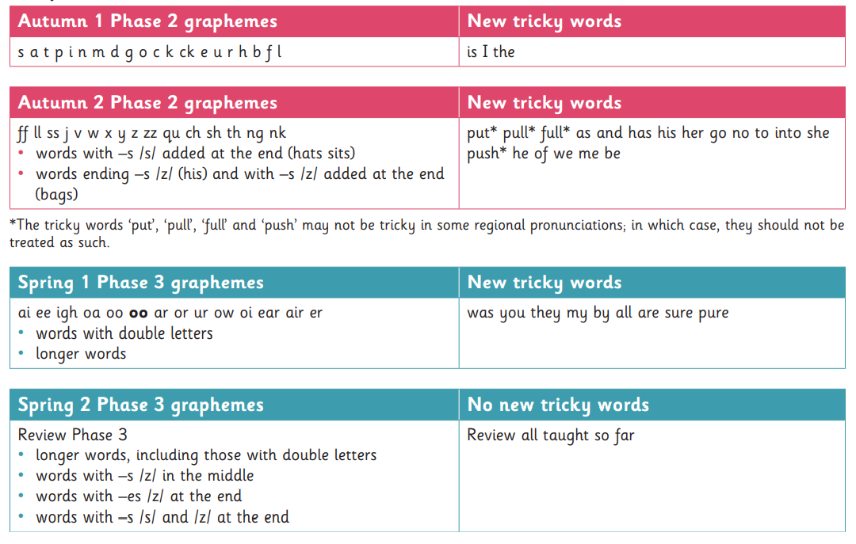
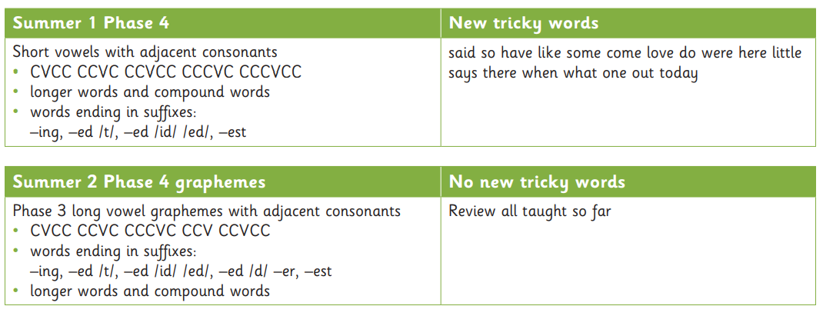

Year 1 Progression Document
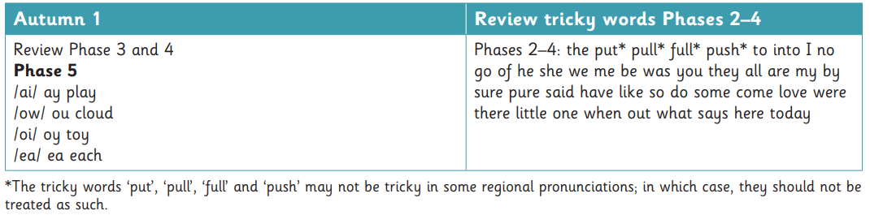
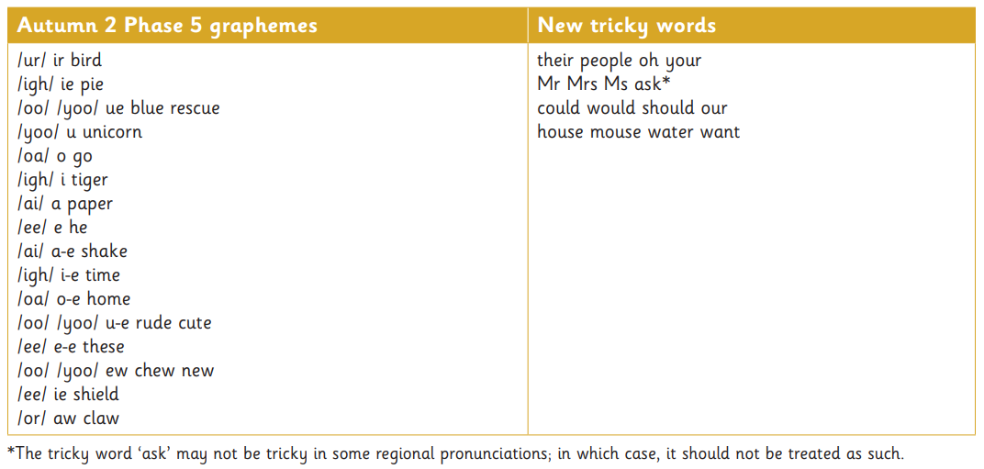

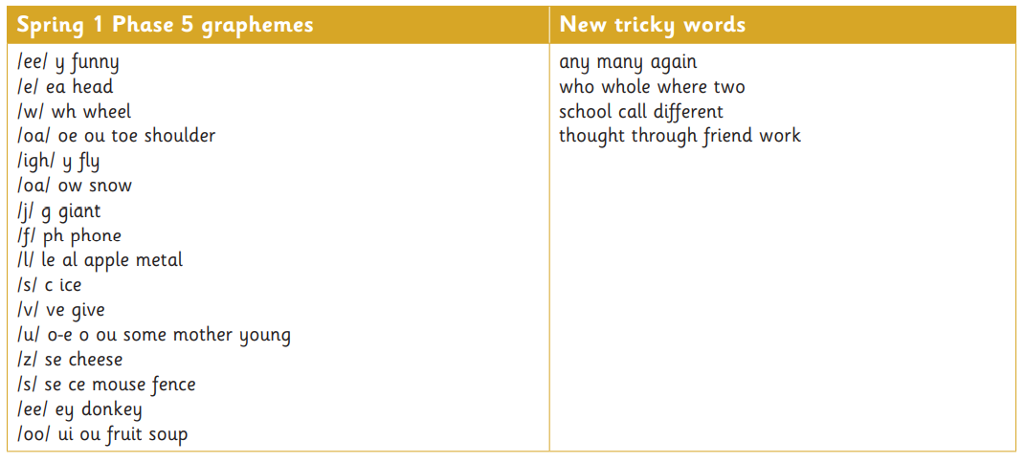
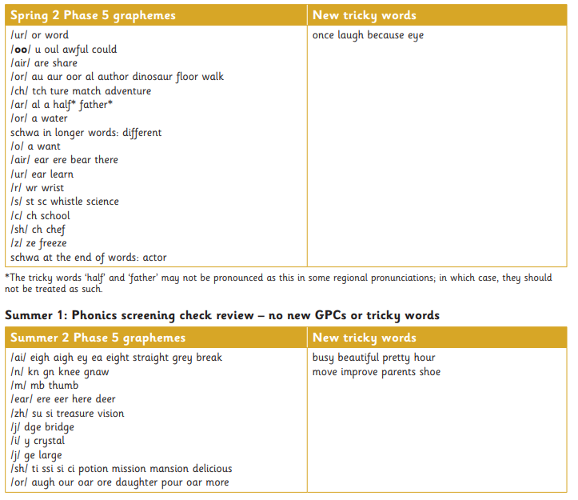

Year 2 Progression Document
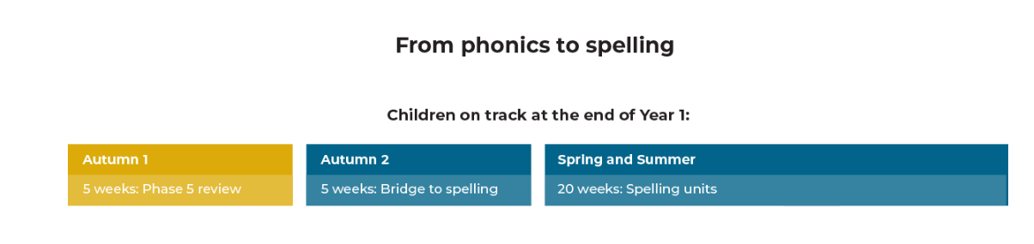
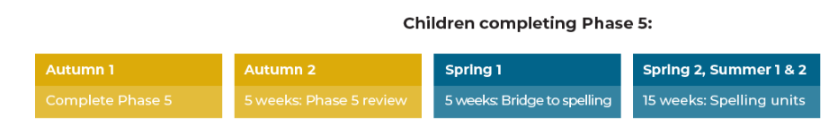
Home Reading
Children will begin to have ‘reading books’ sent home from the summer term of nursery. These will be wordless books and are designed to promote discussion between adult and child in order to support language development and get children into positive reading habits. Children in nursery who are deemed ‘ready’ will have a Collins Big Cat book.
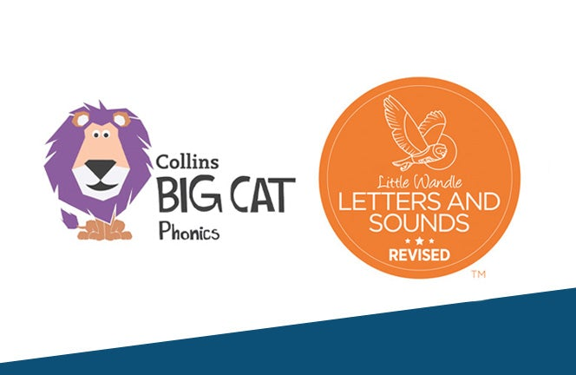
From Reception until the end of Year 1, children will be sent home with two reading books each week. The first of which will be a Harper Collins Big Cat book. This book will be explicitly matched to the GPCs that children have learnt that week in school. This book will not be unfamiliar to the child as they will have read it as part of their thrice weekly reading sessions in school. By the time children read this book with an adult at home, they will be able to read it with around 93% fluency.
Alongside a weekly phonics book, children in Nursery, Reception, Year 1 and Year 2 will also bring home a ‘sharing book’. This will be a text that is beyond the decoding ability of the child, however it is a book they have independently chosen in line with their interests. This gives the children an opportunity to explore books, promote choice, and begin to develop a love of reading. There is no expectation that children attempt to read any of their sharing book independently, instead it is encouraged that an adult at home will read to the child.
Once children have passed their Phonics Screening Check at the end of Year 1, they will have demonstrated that they are now able to independently decode unfamiliar texts with increasing fluency. They will therefore be moved onto being able to choose their own reading books from a selection of fiction and non-fictions texts from our Accelarated Reading Scheme.
If children require additional practise with phonics in Year 2, they will continue to access the Harper Collins Big Cat phonics reading books.

